Words/terms/definitions BEAST Scout
To open the file in windows, go to file, right click and click on “open with live server”
Need Assistance
Lost, delayed, tired, unsure, but stable.
Urgent
Situation is worsening. Darkness, weather, cold, low battery, panic, no water, unsafe terrain, or cannot self-rescue soon.
Emergency
Immediate life threat. Severe danger, trapped, cliff/fall risk, hypothermia signs, child missing, cannot move, or rescue needed now.
Injury / Medical
Any injury or medical issue. This can combine with the tier.
# Navigation Guidance System
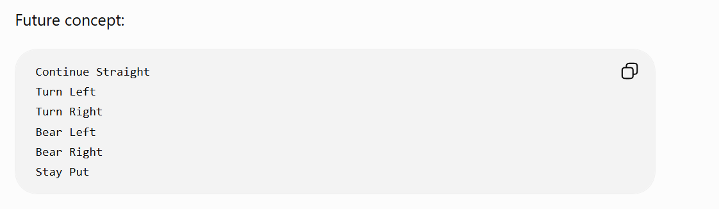
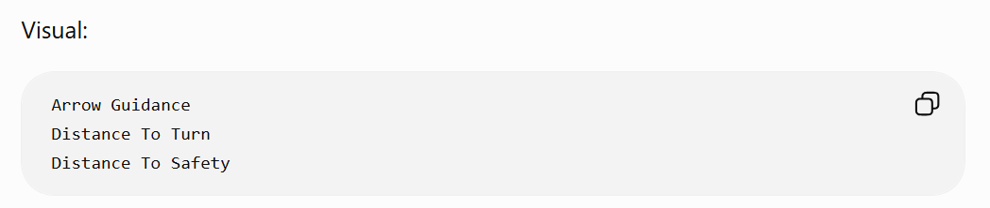
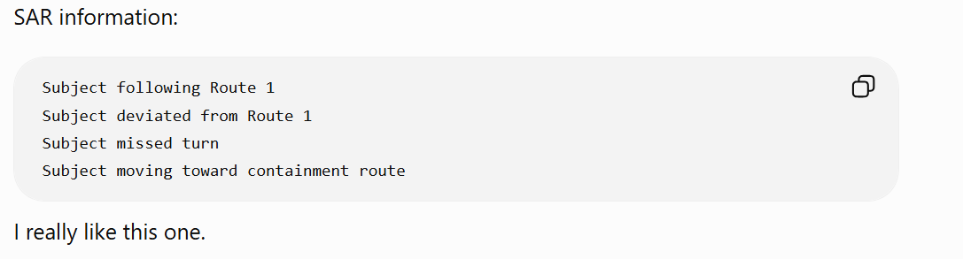
# Route Monitoring
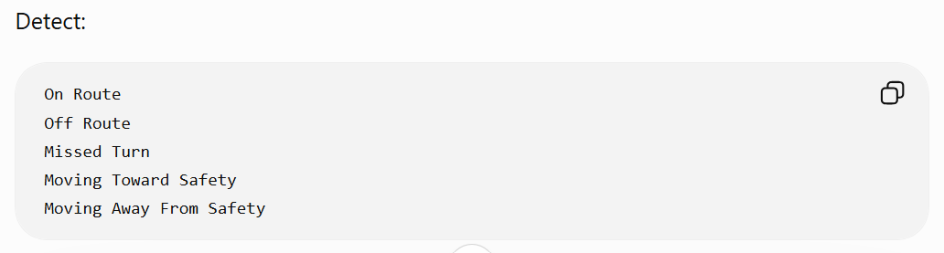
Could feed directly into Agency.
# SAR Features
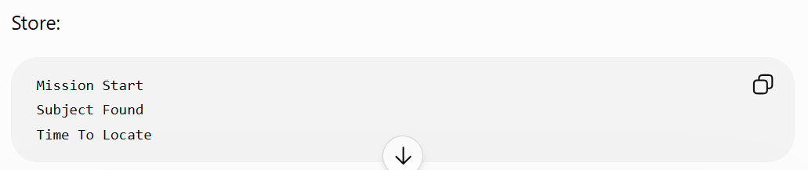
BEAST Response Fund
The promise to users
Something like this:
BEAST never charges victims for rescue. A small portion of each subscription supports training, equipment, and agency-requested response support for areas that may not have enough SAR personnel.
That is powerful because it tells people exactly where the money goes.
The agency version
For agencies, I would say:
Every agency license includes a small BEAST Response Fund contribution. This helps build trained regional support teams that can assist local authorities when requested.
This is important because the agency still stays in charge.
BEAST is not taking over. BEAST is helping.
BEAST Technologies
Builds the app, agency dashboard, data tools, safety scoring, mapping, exports, and subscriptions.
BEAST Response Fund
Pays for training, gear, rural SAR support, and readiness.
BEAST SAR Support Unit
Deploys only when requested by local authority.
That gives us clean lanes.
The ethical rule
This should be carved in stone:
No victim billing. No freelance rescue. No self-deployment. No hero nonsense. Agency-requested support only.
Small counties, rural sheriffs, park systems, and volunteer SAR teams often have the authority and heart, but not always the people, gear, or money.
BEAST could become the thing that helps fill that gap.
Not by replacing them.
By backing them up.
# BEAST K9 module idea
The agency portal could have a dedicated tab:
K9 Operations
Inside it:
K9 team profile
Handler name
Dog name
Certification type
Agency or volunteer group
Contact info
Deployment status
Capabilities
Examples:
Area search
Trailing
Tracking
Human remains detection
Water search
Disaster search
Assignment
Assigned sector
Start time
End time
Search objective
Known hazards
Radio channel
Backup team
Nearest access point
Scent information
Scent article used
Who collected it
Where it was collected
Time collected
Contamination risk
Storage method
Confidence level
This is big, because a bad scent article can mess up the whole search.
K9 field notes
Alert
No alert
Change of behavior
Direction of travel
Track/trail evidence
Handler observation
Environmental note
Possible contamination
Search suspended
Sector cleared
Map markers
BEAST could let the handler or command mark:
Last known point
Scent article location
Dog alert
Dog interest area
No-alert area
Track evidence
Footprint
Clothing/item found
Direction of travel
Water source
Fence crossing
Road crossing
Hazard
SITREP export
Then BEAST exports it cleanly:
K9 Team 2 searched Sector C from 1835 to 1948. Dog showed change of behavior near drainage west of trail junction. No confirmed find. Handler recommends expanding search downhill toward creek bed. Scent conditions limited by wind shift and high foot traffic near trailhead.
That is the kind of note an incident commander can actually use.
Important rule
BEAST should never make the dog’s work sound like magic.
A K9 alert is not automatic proof.
It is a strong clue that needs to be weighed with terrain, time, weather, witness reports, breadcrumbs, and other evidence.
That is where BEAST can shine:
K9 indication + breadcrumb direction + downhill terrain + daylight loss = higher priority search area.
Not because the app is guessing wildly, but because several clues are pointing the same way.
Long-term badass version
Later, BEAST could support:
K9 GPS collar integration
Live handler track
Dog track separate from handler track
Wind direction overlay
Scent cone estimate
Search coverage map
K9 team availability board
Training log
Certification tracker
After-action review
Evidence chain notes
Photo uploads from field
BEAST: Dead Reckoning
A companion navigation survival game built after the main BEAST app is stable. The game mirrors BEAST controls such as breadcrumbs, location send, SITREP, risk check, route choice, and stay-put decisions. It uses a fun zombie woods theme to teach real survival thinking while promoting BEAST in a light, natural way.
The controls could mirror the real BEAST app:
- Drop Breadcrumb
  - Game use: marks where you have been.
  - Real BEAST lesson: your trail history matters if someone has to find you.
- Send Location
  - Game use: sends your current position to “rescue.”
  - Real BEAST lesson: one good location ping can save hours.
- Check Risk
  - Game use: shows route danger, daylight, weather, terrain, and battery.
  - Real BEAST lesson: bad decisions stack up before the emergency happens.
- SITREP
  - Game use: report injury, supplies, battery, weather, and movement.
  - Real BEAST lesson: rescuers need short, useful information.
• Stay Put
- Game use: sometimes the winning move is not moving.
- Real BEAST lesson: moving while lost can make rescue harder.
• Route Choice
- Game use: choose between ridge, creek, trail, road, or shelter.
- Real BEAST lesson: the shortest route is not always the safest route.
# Then, at a natural game moment, we add a small promo:
- You survived because rescue had your last known location.
In the real world, BEAST helps hikers send smarter updates before things go bad.

BEAST App Terms and Definitions
Core BEAST Terms
BEAST
Backcountry Emergency Assessment and Safety Tool.
BEAST is the main safety system. Its purpose is to help hikers, families, outdoor users, and rescue teams make better decisions before and during a backcountry emergency.
BEAST is not just a GPS app. It is meant to combine location, movement, risk, weather, daylight, route choices, and rescue communication into one trusted tool.
BEAST Scout
The early field-testing version of BEAST.
BEAST Scout is the prototype used to test GPS location, breadcrumbs, movement tracking, saved maps, route information, and emergency-style reports before building the full app.
BEAST Agency
The rescue-side version of BEAST.
This is the tool for search and rescue teams, rangers, agencies, incident commanders, and emergency personnel. It would help them view hiker information, breadcrumbs, last known location, route possibilities, SITREPs, and search planning data.
BEAST Community
The public-facing side of the BEAST brand.
BEAST Community would be separate from the emergency app. It could include outdoor stories, trail education, pictures, gear, shop items, training content, and community updates.
BEAST: Dead Reckoning
A future companion game connected to the BEAST brand.
This would be a simple survival/navigation game with a fun zombie woods theme. The controls would mirror the real BEAST app so users learn BEAST-style thinking through play.
The game should teach breadcrumbs, battery awareness, route risk, weather, daylight, SITREP decisions, and stay-put decisions.
Important rule:
Fun game. Serious lesson.
The game should stay clearly separate from the real emergency safety app.

Navigation and Tracking Terms
GPS
Global Positioning System.
GPS is the satellite-based system that helps determine a person’s location. In BEAST, GPS is used to find where the user is, where they have been, and where they may be heading.
GPS Accuracy
How close the GPS reading is likely to be to the person’s real location.
Example:
If the app says accuracy is 15 feet, the person is probably somewhere within about 15 feet of the shown location.
Low accuracy means the location may be unreliable.
Location Ping
A single saved or sent location point.
A location ping can show where the user was at a specific time. In an emergency, even one good ping can help rescuers narrow the search area.
Current Location
The user’s most recent known position.
This is where the app believes the user is right now, based on GPS or the last available signal.
Last Known Location
The most recent reliable location recorded for the user.
This is one of the most important rescue terms in BEAST. If the person disappears, loses signal, or their battery dies, rescuers can start from the last known location.
Breadcrumb
A saved point along the user’s path.
Breadcrumbs create a trail of where the user has been. They can help the user backtrack and help rescuers understand the person’s movement.
Breadcrumb Trail
The full path created from multiple breadcrumbs.
This shows the route the user traveled over time.
Backtrack
Following the breadcrumb trail back toward a previous location.
This can help a user return to a trailhead, campsite, vehicle, or last safe point.
Route
A possible path from one place to another.
In BEAST, a route may be a trail, road, ridge, drainage, creek line, return path, or rescue approach path.
Route Choice
A decision between two or more possible paths.
BEAST should help explain that the shortest route is not always the safest route.
Route Risk
The danger level of a possible route.
Route risk may include distance, terrain, cliffs, water crossings, weather, daylight, injury, battery level, and signal strength.
Containment Route
A route or boundary used by search teams to help limit the search area.
Example:
A road, river, ridge, fence line, or trail could act as a containment route. If the missing person reaches it, rescuers may have a better chance of locating them.
Extraction Point
A location where a person can be safely picked up or rescued.
In a game version, this could be the finish point. In real BEAST use, it could be a trailhead, road, ranger station, landing zone, or safe meeting point.
Safe Zone
A safer location where the user can wait, rest, or meet help.
This could be a trailhead, campsite, road, ranger station, open area, or known landmark.
Hazard Zone
An area with increased danger.
Examples include cliffs, flood areas, steep terrain, water crossings, unstable ground, wildfire areas, severe weather zones, or areas with poor visibility.

Emergency Decision Terms
SITREP
Situation Report.
A short emergency update that tells rescuers what is going on.
A BEAST SITREP may include:
- Current location
- Injury status
- Battery level
- Weather
- Water and supplies
- Movement status
- Last known direction
- Whether the person is staying put or moving
Stay Put
A safety decision where the user stops moving and waits.
This may be the best choice when the user is lost, injured, low on battery, near darkness, in worsening weather, or when rescue already has their location.
Keep Moving
A decision to continue traveling.
This may be reasonable if the user has daylight, battery, good route confidence, no injury, clear terrain, and a known safe destination.
Turn Back
A decision to return the way the user came.
This may be safer than pushing forward into unknown terrain, bad weather, darkness, or low battery.
Shelter in Place
A decision to stop moving and protect yourself from weather, injury, or darkness.
This is stronger than simply “stay put.” It means the person should actively prepare to remain in place safely.
Pre-Emergency
A situation that is not yet an emergency, but could become one.
Examples:
- User is off trail
- Battery is low
- Weather is worsening
- Daylight is running out
- User is tired or injured
- GPS signal is weak
BEAST should help people act before the situation becomes life-threatening.
Emergency Mode
A high-priority app state used when the user needs help.
Emergency Mode should focus on simple controls, location sharing, SITREP, battery preservation, and clear instructions.
Rescue Mode
A rescue-focused state used by responders or agencies.
This would help search teams view location history, breadcrumbs, last known location, route possibilities, and reports.
Panic Choice
A decision made because the person is scared, rushed, or confused.
BEAST should help reduce panic choices by giving calm, simple, safety-focused guidance.
Decision Stack
A chain of small decisions that can lead to safety or danger.
Example:
Low battery plus bad weather plus leaving the trail plus moving after dark creates a dangerous decision stack.
Wobbly Domino
An early warning sign that something may go wrong.
This means a small issue that could start a chain of bigger problems.
Examples:
- Phone battery dropping fast
- Weather changing
- Losing the trail
- Getting tired
- Ignoring daylight
- Poor GPS accuracy

Risk and Assessment Terms
BEAST Assessment
A safety ranking or scoring system inside BEAST.
It helps the user or rescue team understand the seriousness of the situation.
The assessment may look at location, weather, daylight, battery, injury, movement, terrain, and communication.
Risk Score
A simple score showing how risky the situation is.
Example:
Low, Moderate, High, Critical
The score should come with plain-language reasons, not just a number.
Route Ranking
A list of possible routes ranked by safety or usefulness.
Routes should not only be ranked by distance. They should also consider terrain, weather, daylight, battery, injury, and rescue value.
Confidence Level
How sure BEAST is about a recommendation or location.
Example:
High confidence: GPS is accurate, user is on trail, battery is good.
Low confidence: GPS is weak, user is off trail, signal is poor, movement data is limited.
Accuracy Warning
A warning that the location may not be exact.
This matters near cliffs, water, canyons, heavy trees, buildings, or poor satellite coverage.
Safety Recommendation
A suggested action based on the user’s situation.
Examples:
- Stay put
- Send location
- Turn back
- Shelter in place
- Avoid water crossing
- Save battery
- Follow breadcrumb trail
Why List
A short explanation of why BEAST is making a recommendation.
Example:
Recommendation: Stay put.
Why:
- Sunset is in 35 minutes
- Battery is at 12%
- Weather is worsening
- Last known location has been saved
- Moving may make rescue harder
Boring Reliability
A core BEAST design idea.
It means the app should be trusted, simple, stable, and dependable. It should not be flashy if flashiness makes it confusing or unsafe.

Terrain and Environment Terms
Terrain
The physical land around the user.
Examples:
- Flat trail
- Steep hill
- Cliff
- Creek
- Ridge
- Canyon
- Forest
- Road
- Open field
Elevation
How high a location is above sea level.
Elevation matters because a person may be above or below rescuers, especially near cliffs, steep hills, canyons, or drop-offs.
Altitude
Often used like elevation in outdoor apps.
In BEAST, altitude can help show whether someone is on top of a cliff, below a cliff, in a canyon, or on a slope.
Cliff Risk
The danger that a GPS point may lead rescuers to the wrong vertical position.
Example:
GPS may show the person near a cliff edge, but the person may actually be at the bottom after a fall.
Drainage
A low area where water flows downhill.
People sometimes follow drainages when lost, but drainages can also lead to cliffs, thick brush, dangerous water, or hard terrain.
Ridge
A high line of land between lower areas.
Ridges may help with visibility or signal, but they can also expose the user to weather, wind, lightning, and steep drops.
Water Crossing
A place where the user must cross a creek, stream, river, or flooded area.
Water crossings can be dangerous, especially in cold, fast, deep, or low-visibility water.
Landmark
A recognizable feature that helps identify location.
Examples:
- Road
- Bridge
- Trail sign
- Creek
- Rock formation
- Cabin
- Campground
- Power line
- Trail junction

Communication Terms
Signal
The user’s ability to communicate by cell, satellite, radio, or internet connection.
Signal Loss
When the device can no longer communicate.
BEAST should still save important information offline when signal is lost.
Offline Mode
A mode where BEAST keeps working without internet or cell signal.
It should continue saving breadcrumbs, location data, notes, and maps when possible.
Opportunistic Sync
Sending saved information when a connection becomes available again.
Example:
If the user loses signal, BEAST keeps saving data. When signal returns, it sends the saved updates.
Emergency Contact
A person who can receive alerts or location updates from the user.
Agency Contact
A rescue group, ranger station, emergency agency, or official responder contact connected to BEAST Agency.
Location Share
Sending the user’s location to another person or agency.
Rescue Update
A message sent to or from rescuers during an emergency.

Device and Tracking Terms
Phone Tracker
Location tracking based on the user’s phone.
Watch Tracker
Location tracking based on the user’s smartwatch.
Active Tracker
The device currently believed to be closest to the person.
Example:
If the phone stops moving but the watch keeps moving, BEAST may treat the watch as the active tracker.
Device Separation
When the user may have become separated from one of their devices.
Example:
The phone may have been dropped, but the watch is still moving with the person.
Dropped Phone Warning
A warning that the phone may no longer be with the user.
Example:
The phone is stationary, but the watch continues moving.
Tracking Hardware
A device used to help locate a person, child, pet, or gear.
Examples:
- Phone
- Smartwatch
- Satellite messenger
- Bluetooth tracker
- Apple AirTag-style tracker
- BEAST future hardware
Guardian Band
A future wearable idea for children, disabled users, elderly users, or anyone at higher risk of wandering or becoming separated.
The idea is a wristband, necklace, or clip-on tracker that helps caregivers and responders locate the person.

Agency and Rescue Terms
Incident Commander
The person in charge of managing a rescue or emergency response.
BEAST Agency should give this person short, clear, useful information.
Search and Rescue
Usually shortened to SAR.
The organized effort to find, assist, and rescue a missing or injured person.
SAR Team
The people actively involved in search and rescue work.
Search Area
The area where rescuers believe the missing person may be.
Search Segment
A smaller piece of the search area assigned to a team.
Last Known Point
A location where the missing person was confirmed to be.
This is very close to last known location, but often used in search and rescue planning.
Point Last Seen
The place where someone was physically seen for the last time.
This may be different from the last GPS location.
Movement Pattern
The direction, speed, and behavior shown by the user’s location history.
This can help predict where the person may go next.
Route Probability
An estimate of which route the person most likely took.
This should be treated carefully because it is an educated guess, not a guarantee.
Search Priority
The order in which areas or routes should be checked.
High-priority areas may include likely routes, dangerous terrain, last known location, water, cliffs, or containment routes.
After Action Review
A review after an incident or test.
The purpose is to learn what worked, what failed, and what should improve.
Lessons Learned
Important knowledge gained from real incidents, testing, ranger experience, or SAR experience.
Legacy Library
A future BEAST Agency Portal feature.
The Legacy Library would collect wisdom, field knowledge, templates, lessons learned, and experience from retired rangers, SAR members, and outdoor professionals.
Ranger Knowledge Library
A knowledge base for useful field information.
This could include local terrain risks, common problem areas, weather patterns, rescue lessons, trail notes, and agency-specific knowledge.
Problem Area
A location where incidents happen often.
Examples:
- Confusing trail junction
- Cliff area
- Flash flood crossing
- Weak signal zone
- High heat area
- Snow or ice danger zone
Incident Analytics
Using past incident data to find patterns.
Example:
If several rescues happen near the same trail junction, BEAST could flag that area as a known problem spot.

Report and Export Terms
Export
Saving BEAST data into a file that can be shared or reviewed.
Examples:
- Breadcrumb export
- Map export
- SITREP export
- Incident report export
Scout Export
Exporting information from BEAST Scout.
This could include breadcrumbs, route history, map image, location points, timestamps, and test notes.
Agency Import
Bringing Scout data into the Agency side.
This would allow rescue teams or reviewers to see the user’s route, breadcrumbs, SITREP, and map data.
Map Snapshot
A saved image of the map at the end of a tracking session.
This gives the user or rescue team a quick visual record of the route.
HTML Map File
An interactive map saved as an HTML file.
This could show breadcrumbs, route path, start point, stop point, and important markers.
PDF SITREP
A clean PDF version of the situation report.
This would be useful for sharing with rescue teams, agencies, testing records, or after action review.
Test Report
A report made after a field test.
It may include location accuracy, breadcrumb performance, map save results, battery use, signal problems, and user notes.

App Control Terms
Drop Breadcrumb Button
A button that manually saves the user’s current location.
Start Tracking Button
A button that begins recording location and breadcrumbs.
Stop Tracking Button
A button that ends tracking and may save the map, breadcrumb trail, and report.
Send Location Button
A button that sends the current location to a contact or agency.
Check Risk Button
A button that runs the BEAST Assessment and gives a risk result.
SITREP Button
A button that opens or sends a short situation report.
Stay Put Button
A button that tells BEAST the user is stopping and staying in place.
Route Options Button
A button that shows possible routes or decisions.
Emergency Button
A button for high-priority emergency action.
This must be designed carefully to avoid accidental use while still being easy to reach during a real emergency.

Game Terms for BEAST: Dead Reckoning
Dead Reckoning
A real navigation method where a person estimates position based on direction, distance, speed, and time.
For the game name, it also creates a zombie survival feeling.
BEAST: Dead Reckoning
A future BEAST-themed survival/navigation game.
The game teaches users how to use BEAST-style controls while surviving a fictional woods emergency.
Zombie Woods
The fun theme layer for the game.
The zombies add pressure, but the real lesson is navigation and survival decision-making.
Threat Zone
A dangerous area in the game.
This could represent zombies, bad terrain, weather danger, low visibility, or high-risk movement areas.
Noise Level
A game mechanic showing how much attention the player is attracting.
Running, breaking branches, or moving through brush may increase noise.
Battery Level
A game mechanic that teaches battery management.
Using GPS, flashlight, map, communication, or risk checks could drain battery.
Daylight Timer
A game mechanic showing how much daylight remains.
As daylight drops, risk increases.
New BEAST Feature: Daylight Timer
When the user hits Help, Emergency, or maybe even I’m Not Sure / I Might Be Lost, BEAST shows:
Sunset in: 1 hour 17 minutes
Then underneath it gives plain guidance:
Daylight is limited. Decide now whether to stay put, turn back, or prepare shelter.
That is powerful because people do dumb stuff when they think they have more time than they really do. Darkness changes everything.
Why this matters
Daylight affects:
- Navigation
- Injury risk
- Temperature risk
- Rescue visibility
- Panic
- Battery use
- Shelter decisions
- Terrain danger
- Water crossing danger
- Whether moving is still smart
So BEAST could treat daylight like a major safety variable, not just a clock.
How it could work in the app
If sunset is more than 3 hours away
BEAST could say:
You still have useful daylight, but conditions can change fast. Save your location and check your route before moving.
If sunset is 1 to 3 hours away
BEAST could say:
Daylight is limited. Avoid unknown routes. Consider turning back, staying put, or moving only toward a known safe location.
If sunset is under 1 hour away
BEAST could say:
Sunset is close. Moving through unknown terrain may increase risk. Send your location, conserve battery, and prepare to stay in place unless you are certain of your route.
If it is already dark
BEAST could say:
It is now dark. Avoid unnecessary movement. Send location, conserve battery, stay warm, and make yourself easier to find.
Button idea
When Help is pushed, the emergency screen could show four big things:
- Current Location
- Battery Level
- Daylight Timer
- Send SITREP
That is clean and not cluttered.
Even better
The Daylight Timer should change the BEAST Assessment.
Example:
Risk increased because:
- Sunset is in 42 minutes
- Battery is 18%
- You are off trail
- GPS accuracy is weak
- Weather is worsening
Recommendation:
Stay put and prepare shelter.
That right there is BEAST doing what BEAST is supposed to do: stopping a bad decision before it becomes a rescue nightmare.
After sunset
Risk becomes a major factor.
BEAST should discourage unnecessary movement unless staying put creates greater danger.
Clean phrase for the app
Daylight is running out. Make your next decision before darkness makes it for you.
That line might be a little intense, but man, it is true.

Weather Timer
A game mechanic showing when bad weather will arrive.
The player must make decisions before weather worsens.
Extraction
The act of reaching safety or being rescued.
Survival Lesson
The short lesson shown after a game event or mission.
Example:
“You survived because rescue had your last known location.”
BEAST Promo
A light in-game message that connects the lesson to the real BEAST app.
Example:
“In the real world, BEAST helps hikers send smarter updates before things go bad.”

Brand and Safety Terms
Helping People Get Outside With Confidence
A BEAST motto.
This means BEAST should encourage outdoor adventure while helping users make safer decisions.
Safety First Design
The design rule that BEAST should put user safety above style, speed, or flashy features.
Trust Layer
The part of BEAST that helps users and agencies trust the information.
This includes accuracy, timestamps, confidence levels, clear warnings, and plain-language reasoning.
Verified Update
Information confirmed by a trusted source, ranger, agency, or official user.
Unverified Update
Information that has been submitted but not confirmed.
Unverified information should be clearly labeled so users do not treat it as fact.
Information Stream
A separated category of updates.
Example:
- Weather
- Trail conditions
- Agency alerts
- Community posts
- Gear/shop content
- Education
Adventure Feed
A limited social-style feed for outdoor updates, photos, and community activity.
Important note:
This should not clutter the main safety app.
BEAST Core
The serious safety and emergency app.
BEAST Expansion
Future additions connected to the BEAST brand, such as BEAST Community, Agency Portal, shop, education, and Dead Reckoning.
Robust and Trusted Product
A product that works reliably and safely.
This means BEAST should be tested hard before adding flashy features.
Break It Testing
Field testing where the goal is to find problems before real users depend on the app.
This is important because BEAST could affect real safety decisions.

# Conversations with BOB
Bob, continuing BEAST Scout from the last conversation.
Current file lock:
app.html
Current rule:
Browser-only. Do not convert to app.py or Flask.
Last working part:
The map was working.
Next task:
Add/repair _______.
Give me one complete clean copy-paste file.

Page Ideas and Layout
# Map Page
The Map page should answer:
Where am I?
Where have I been?
Where am I trying to go?
What is around me?
What is the safest move right now?
Map page tools
Main map screen
Always visible:
Current location
Breadcrumb trail
Accuracy circle
Altitude
Last known location
Start / Stop / Reset tracking
Map Tools drawer
A button called: Map tools
Inside that drawer:
Plot Course
Measure Distance
Set Waypoint
Set Start Point
Set Destination
Drop Marker
Clear Markers
Save Map
# Map types:
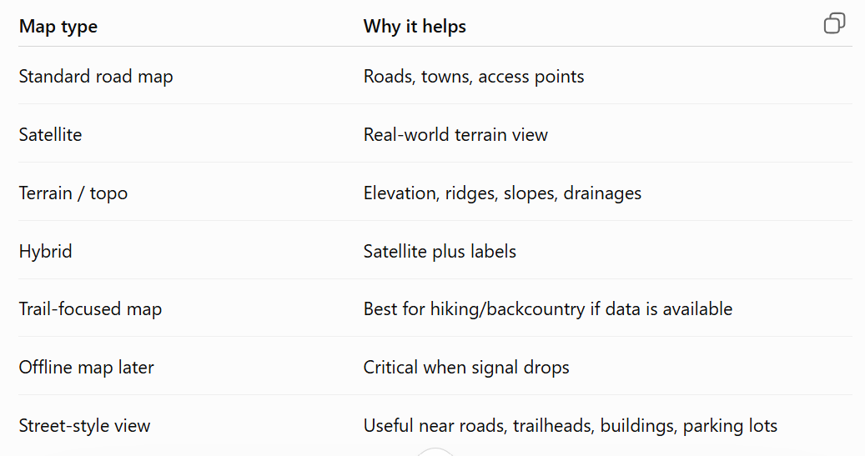
# AI route brain
It should say:
Recommended route: Route A
Confidence: Moderate
Why:
- Shortest route back to known road
- Avoids steep terrain
- Keeps user near previous breadcrumb trail
- Sunset in 48 minutes
- Battery is 22%
- GPS accuracy is fair
# Route confidence score
High confidence
Moderate confidence
Low confidence
Not enough information
# What the AI should consider
Distance
Terrain
Elevation change
Altitude
Known trail/road access
Breadcrumb path
Last known location
GPS accuracy
Battery level
Daylight remaining
Weather change
User injury status
User movement ability
Signal strength
Water crossings
Steep slopes
Cliffs/ravines when data is available
Recommendation examples:
Sunset coming soon:
Recommendation: Stay put or move only to a safer nearby location.
Reason: Sunset is approaching, battery is low, and GPS accuracy is weak.
Weather worsening:
Recommendation: Stop moving, send SITREP, prepare shelter, conserve battery.
Reason: Weather is worsening and continued movement may increase risk.
# Recommended Map page structure:
Page 2 of 5: Map
Top:
- Tracking status
- Accuracy
- Altitude
- Battery
Middle:
- Map
- Breadcrumbs
- Current location
- Waypoints
Bottom overlay:
- Start Tracking
- Stop Tracking
- Reset
Map Tools drawer:
- Plot Course
- Measure Distance
- Set Waypoint
- Set Start Point
- Set Destination
- Change Map Type
- Save / Export

AI Route Brain panel:
- Recommend Route
- Confidence
- Why
- What to do now
# Safety rule for the AI brain:
BEAST should explain recommendations.
BEAST should not pretend to know more than the data supports.
# So when the data is weak, it should say that clearly:
Confidence: Low
Reason: GPS accuracy is poor and terrain data is limited.
Recommendation: Stay put, send SITREP, conserve battery, and avoid moving into unknown terrain.
# Best phased plan:
Phase 1: Map basics
Current location
Breadcrumbs
Accuracy circle
Altitude
Last known location
Start / Stop / Reset
Phase 2: Map tools:
Waypoints
Measure distance
Set start point
Set destination
Save map
Phase 3: Map views:
Standard
Satellite
Terrain / topo
Hybrid
Phase 4: AI route brain:
Route options
Confidence score
Reasons
Risk warnings
Daylight/weather/battery guidance
Phase 5: Advanced rescue support:
Agency import
Route ranking
SAR-friendly export
Shared last known location
Offline map package
# What weather data BEAST should check:
Step by step, I would have BEAST check:
- Current conditions
  - Temperature
  - Wind
  - Rain/snow
  - Visibility if available
- Forecast
  - Next 1 hour
  - Next 3 hours
  - Overnight risk
- Active alerts
  - Thunderstorm warning
  - Flash flood warning
  - Winter storm warning
  - Red flag/fire warning
  - High wind warning
- Location risk
  - User altitude
  - Nearby terrain
  - Possible low area, drainage, ridge, exposed slope
  - Distance from trail/road/known point
- Data quality
  - How old is the weather update?
  - Is GPS accuracy good?
  - Is signal stable?
  - Is the weather source reliable?

